**After creating the order in ebiz, Release Order in Ebiz to WMS (VDC order) and RB(KDC orders)**

1. To Release the order, change the responsibility to Order Management Super User.
2. Select Release Sales Orders and open

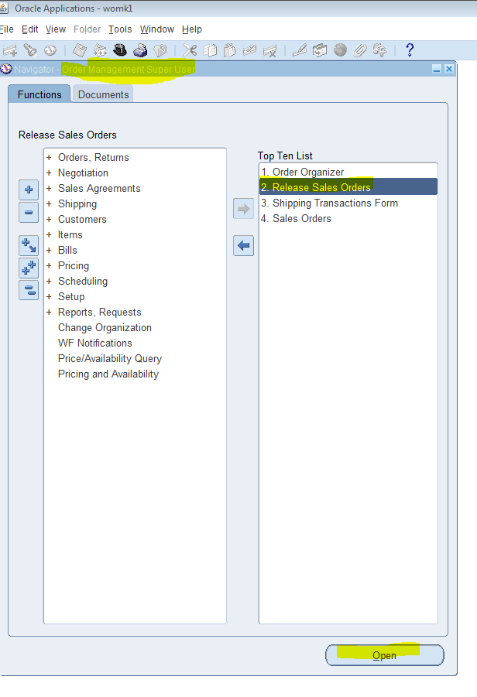

1. Below window will open, click the … sign ‘Based On Rule’

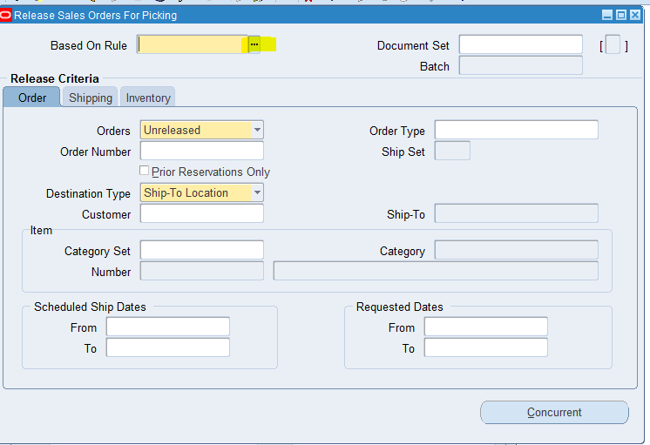

1. Do a wild card search and click the LDB_VDC or LDB_KDC depending on the order.

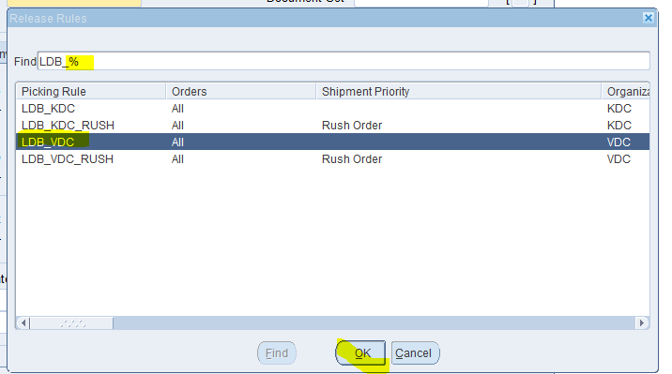

1. In the next screen. Enter Order Number. Uncheck the Prior Reservations Only (for INT4) and click Concurrent.

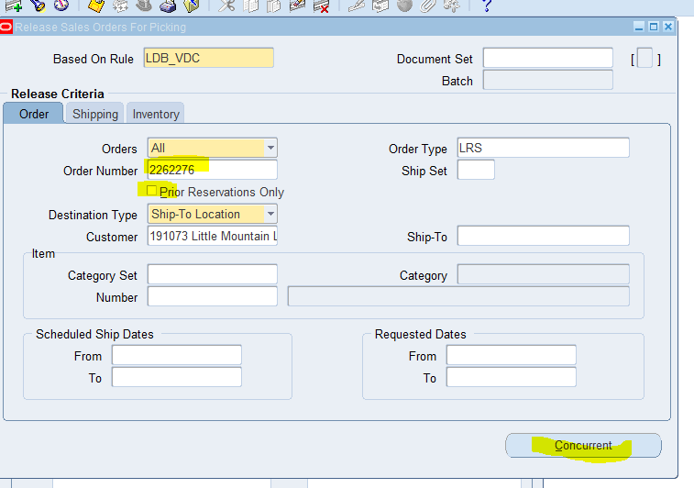%

1. Request id will be displayed. Click ok

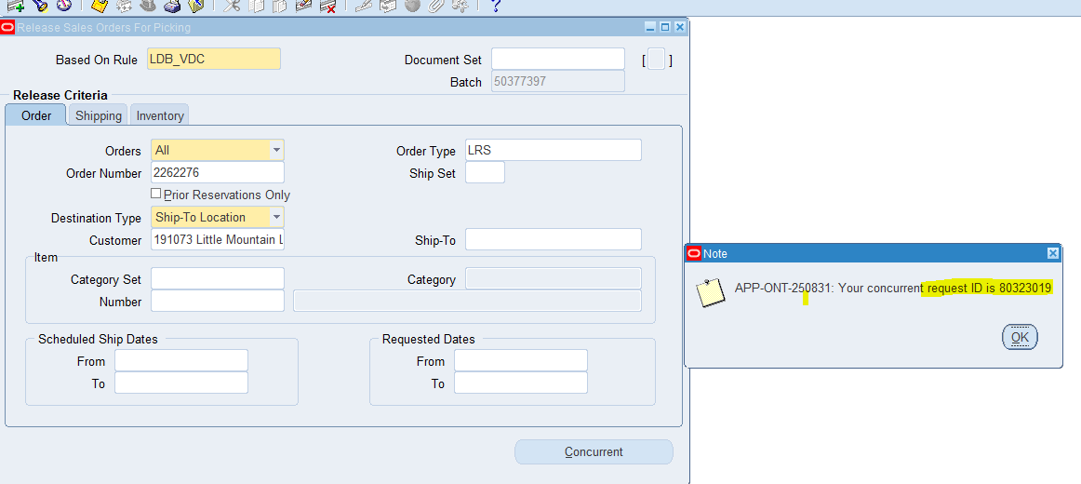

1. On home screen Select Order Organizer. Click Open

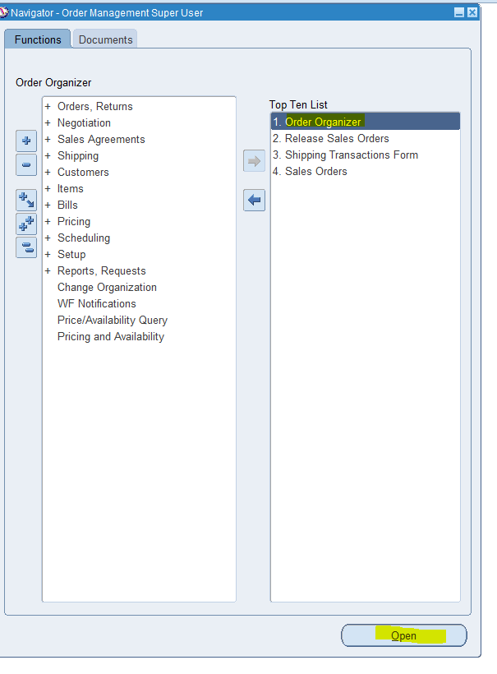

1. Enter Order number. Click Find.

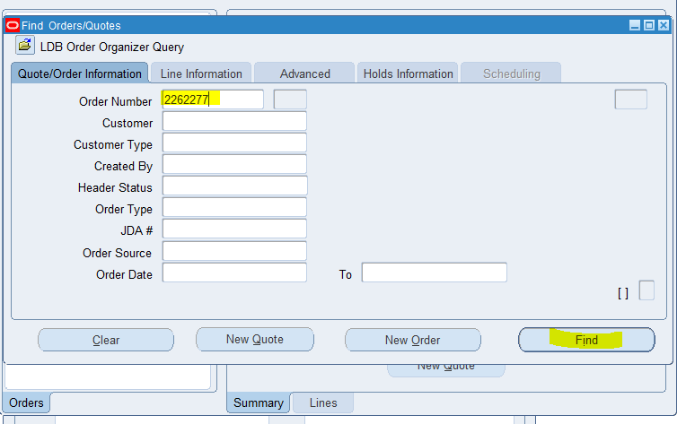

1. Click Action

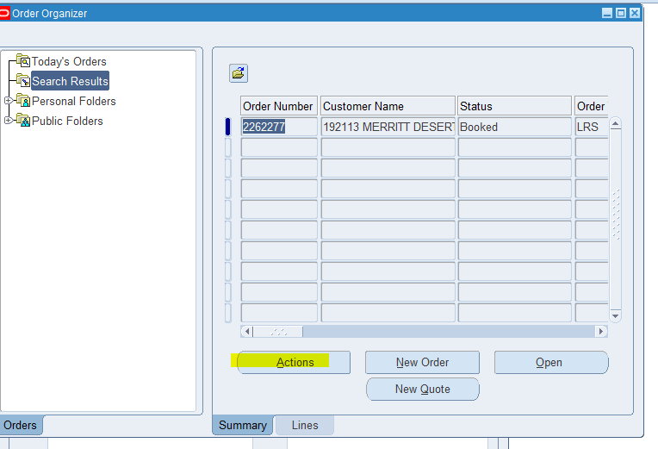

1. Click Additional Order Information. Hit Ok

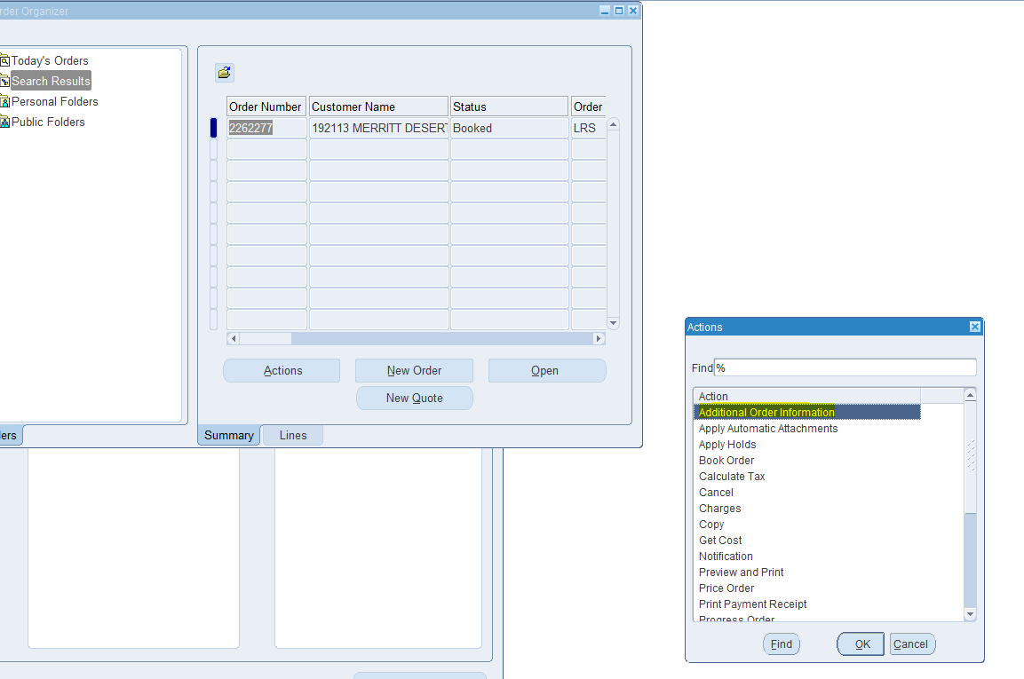

1. Click Deliveries tab on the next screen and note the Delivery ID.

